EXECUTIVE OFFICE OF ENERGY & ENVIRONMENTAL AFFAIRS

Richard Sullivan, Jr., Secretary

Contract for Services Opportunity Announcement

RFR ENV 14 CZM 02

Dated: July 24, 2013

Climate Change Vulnerability Assessment and Adaptation Planning Study for Water Quality Infrastructure in New Bedford, Fairhaven and Acushnet

1. Contract for Services RFR Summary:

A. Proposals Sought For: A Climate Change Vulnerability Assessment and Adaptation Planning Study for Water Quality Infrastructure in New Bedford, Fairhaven and Acushnet. The overall goal of this effort is to improve public and governmental understanding of the vulnerabilities of public infrastructure in the three communities with future sea level rise and potential increased precipitation, frequency and intensity of storms, and coastal storm surges.

B. Overview and Goals: The Executive Office of Energy and Environmental Affairs (EEA), through the Buzzards Bay National Estuary Program (NEP) in the Massachusetts Office of Coastal Zone Management (CZM), announces the availability of $22,172 in federal funds to hire an environmental service or planning firm to conduct a climate change vulnerability assessment and adaptation planning effort for the municipalities surrounding New Bedford Harbor. The purpose of this project is to develop an understanding of possible impacts of climate change and potential future responses by the Towns of Acushnet and Fairhaven, and the City of New Bedford. Of specific concern is how future increases of sea level, precipitation, and frequency or intensity of storms may affect public infrastructure related to water quality and habitat protection. The purpose of this Request for Responses is to select a vendor to adequately characterize the potential climate change vulnerabilities to certain public infrastructure, quantify populations at risk, and identify and prioritize possible adaptation strategies. This work is part of a national effort by the US Environmental Protection Agency to encourage municipalities to enact long-term strategies to adapt to anticipated climate change impacts.

C. Eligible Proposals: Eligible proposals are those that will employ suitable methodologies (use of LiDAR data, municipal infrastructure survey records, GIS data sets, etc.) to adequately characterize the potential climate change impacts to certain public infrastructure, quantify populations at risk, and identify and prioritize possible adaptation strategies.

D. Eligible Applicants: Any qualified environmental service or planning firm that is responsive to this RFR, who meets the submission requirements and whose budget does not exceed $22,172 is eligible.

E. Application Deadline: Thursday, September 5, 2013 by 4:00 PM (See further detail in section 4).

F. Funding Availability: A total of $22,172 in federal funds is available through this solicitation. The final funding amount is subject to approval. Exceptions may be made at the Secretary’s discretion (see further detail on Funding Availability in section 2C).

G. Total Anticipated Duration of Contract(s): The contract will last approximately five months, with the contract (expected to be) issued with a October 1, 2013 notice to proceed, with a closing date of February 28, 2014.

H. Regulations, Statutes, or Authorization Governing this Contract for Services Opportunity: Cooperative agreements between the Commonwealth of Massachusetts and the US EPA, in support of the Buzzards Bay National Estuary Program, and all relevant Massachusetts state laws and regulations govern this contract for services.

I. Small Business Purchasing Program: This is a small procurement targeted to small businesses participating in the Commonwealth's Small Business Purchasing Program (SBPP). The Department intends to evaluate bid responses from and to award a contract to a SBPP-participating business(es) who submit a bid that meets or exceeds the solicitation criteria only. Subcontracting in these types of procurements is limited to no more than 20% of the value of the contract, unless it is with another SBPP registered participant. If determined that there is inadequate SBPP capacity, or no SBPP-participating vendors provide a responsive bid, the Department will evaluate and award bid responses received from non-SBPP businesses. To determine eligibility and to participate in the SBPP, please review the requirements and general program information at www.mass.gov/sbpp

J. Contact Information: Sarah Williams, Regional Planner
Buzzards Bay National Estuary Program/CZM
2870 Cranberry Highway
East Wareham, MA 02538
Phone (508) 291-3625 ext 13
Fax (508) 291-3628
sarah.williams@state.ma.us
Website: buzzardsbay.org

2. Performance and Contract Specifications

A. Eligible Applicants: Eligible applicants include any qualified environmental service or planning firm that is responsive to this RFR, who meets the submission requirements and whose budget does not exceed $22,172.

B. Eligible Project(s)/Scope(s) of Work:
Overview
The Buzzards Bay National Estuary Program (Buzzards Bay NEP) announces the availability of $22,172 in federal funds to hire an environmental service or planning firm to conduct a climate change vulnerability assessment and adaptation planning effort for the municipalities of Acushnet, Fairhaven, and New Bedford. The purpose of this project is to develop an understanding of possible impacts of climate change and potential future responses by the Towns of Acushnet and Fairhaven, and the City of New Bedford. Of specific concern is how future increases of sea level, precipitation, and frequency or intensity of storms may affect public infrastructure related to water quality and habitat protection. The purpose of this Request for Responses is to select a vendor to adequately characterize the potential vulnerabilities to climate change on certain public infrastructure, quantify populations at risk, and identify and prioritize possible adaptation strategies. This work is part of a national effort by the US Environmental Protection Agency to encourage municipalities to enact long-term strategies to adapt to anticipated climate change impacts.

Goals of the effort
The overall goal of this effort is to improve public and governmental understanding of the vulnerabilities of the Towns of Acushnet and Fairhaven and the City of New Bedford to future sea level rise and increased precipitation, frequency and intensity of storms, and coastal storm surges. Understanding will be achieved through maps, meetings, workshops, GIS data, a report, and information posted on a website. The report shall outline adaptation strategies and retrofit actions that could be implemented by the three participating municipalities. The information and recommendations in the report can guide municipalities to develop and implement climate adaptation strategies. These strategies will inform future changes in regulations, policies, site construction standards, and infrastructure maintenance planning. The specific outlined strategies in the final report can be used by the municipalities to develop grant applications to state and federal agencies. The report should identify potential funding sources for the recommended actions. The ultimate goal is that information, strategies and actions will lead to a reduction in long-term vulnerabilities of the public and municipal infrastructure and private properties susceptible to the effects of climate change.

Background
The Buzzards Bay NEP and Massachusetts Office of Coastal Zone Management (MA CZM) have jointly conducted a draft evaluation of sea level rise impacts, using LiDAR data, to New Bedford Harbor and surrounding areas. The harbor, which is shared by the City of New Bedford and the Towns of Acushnet and Fairhaven, is of interest because it is protected by a hurricane barrier that was constructed by the US Army Corps of Engineers in the early 1960s. The barrier and dikes protect a heavily urbanized and industrial area, an environmental justice community (see Figure 1 in Attachment A), a nationally important fishing fleet, and a center for the seafood processing industry. The area not protected by the hurricane barrier was also studied by the Buzzards Bay NEP and is of interest to this study as well. About 50% of the Buzzards Bay watershed population lives in these three communities.

The Buzzards Bay NEP has found that the hurricane barrier will potentially have a widespread failure from the 1% storm ("100-year storm event") in conjunction with a four-foot sea level rise scenario (see Fig. 2 in Attachment A). Under lesser sea level rise scenarios, and coupled with expected higher annual rainfalls and more intense storms, the wastewater treatment facility, CSO system, and the municipal stormwater networks of each community may be appreciably impacted. The New Bedford Wastewater facility at the southern end of Clarks Point, and a community wastewater facility on West Island in Fairhaven are also of concern. These issues, and other potential concerns related to climate change, need to be enumerated and characterized for the three communities involved. This task will be met primarily through hiring a contractor to evaluate existing data and information, assess risk, and characterize existing issues and needs relating to potential climate change impacts (sea level rise, increased precipitation, potential increased storm intensity and frequency) that may require adaptation strategies in the three communities.

Scope of Work and Tasks
To accomplish this work, the contractor will conduct a vulnerability assessment using existing reports, GIS and other data sets including, but not limited to, US Army Corps and FEMA flood zone maps, flooding assessments and studies relating to the New Bedford-Fairhaven Hurricane Barrier, LiDAR coverages, coastal erosion assessments, CZM studies of beach erosion, infrastructure, parcel, and assessor data for the area. The work of the vendor shall consider the findings contained in the "Results from a VCAPS Planning Workshop for Extreme Weather and Climate Change in New Bedford and Fairhaven, Massachusetts" (Webler et al., 2012). The contractor will also incorporate findings of existing studies, including, but not limited to the Buzzards Bay NEP's studies of the expansion of coastal floodplain with sea level rise. Like other Buzzards Bay NEP sea level rise assessments, the contractor will consider conditions associated with 1-, 2-, and 4- feet increases in sea level and a 50-year planning horizon.

The contractor will identify pump stations, CSO discharges, wastewater treatment facilities, pipe elevations and junctions, and other infrastructure in the three municipalities that may need to be modified or relocated to ensure their proper operation with either sea level rise or increased stormwater flows. Maps will also be prepared to show where flooding has occurred or stormwater or wastewater infrastructure has failed or overflowed during exceptionally heavy rains. The contractor will use this information to prepare maps identifying the areas currently impacted, and likely to be further impacted by increasing amounts, intensity, or frequency of precipitation or storms. The maps and collected information will be used to illustrate vulnerable areas and infrastructure in order to promote dialog and understanding. The primary target audience of the effort is municipal officials, boards, and legislative bodies. The planning area includes environmental justice populations. For example, the contractor may consider identifying areas of the coast where protection of the shore from sea level rise or coastal erosion may be important, where infrastructure should be elevated, and where publically funded intervention of coastal erosion and inundation are not recommended. The final report could also include recommendations for changes to local bylaws, ordinances, and regulations that could help better plan for and accommodate impacts.

The Buzzards Bay NEP, in partnership with MA CZM, and the affected communities, will invite area municipal officials, agency staff, the Buzzards Bay Action Committee (a non-profit organization composed of municipal officials), and other partners concerned about the impacts of climate change on New Bedford Harbor and surrounding areas to participate in the meetings and a workshop to help guide this initiative. Based on guidance and feedback from meeting participants and ad hoc reviewers, the Buzzards Bay NEP will oversee the contractor under this RFR and set priorities.

The goal of the workshop (Task 3c) and the recommendations meetings is to both introduce core concepts about climate change, to discuss preliminary findings, and develop and refine recommendations of the contractor. The Buzzards Bay NEP will work with the contractor to identify any appropriate additional presenters for the half-day workshop.

The principal products to be produced by the vendor are a final report, companion wall maps that inventory sensitive water quality infrastructure facilities and natural resources, GIS data sets (with sufficient metadata), and supporting information for posting online. The report shall have two sections corresponding to Task 1 and Task 2. The workshops and meetings are in support of these tasks.

With the Buzzards Bay NEP guidance, the contractor will create interactive webpages with information developed by this project. The selected contractor will provide products to post on this website that will be a pre-established sub-domain of buzzardsbay.org, climate.buzzardsbay.org.

All products will be developed as draft and draft final, subject to Buzzards Bay NEP and project partner review (the Buzzards Bay NEP will combine comments as a single submission). The Buzzards Bay NEP will prepare written comments within 15 working days for products based on meetings and guidance from the participating municipalities.

Task 1- Data Inventory, Collection, and Analysis
The contractor shall inventory, characterize, and assess relevant data sets from the municipalities of New Bedford, Acushnet, and Fairhaven, including but not limited to identifying stormwater systems of insufficient capacity, quantification of structures or populations at risk, records of areas affected by storms or annual high tides, flood records, vulnerabilities in the existing coastal floodplain, and relevant local regulations, laws, and policies that relate to development in flood zones, reconstruction after storms, and maintenance and upgrades of infrastructure. The contractor shall characterize vulnerabilities, and identify adaptation strategies and priorities for the area of study. Examples of key water quality infrastructure that may be impacted include (but not limited to) all discharge points (existing mapped stormwater discharge and CSO locations), wastewater treatment facilities (3), tide gate structures and regulator structures. Potential impacts of increased storm intensities, precipitation, increases in near coastal water tables, and increased tidal influences on inland structures should be characterized and assessed. For example, the contractor should identify flow regulators that may be overcome by increases in tidal elevations and where seawater flow may enter sewer systems from the seaward side of regulators.

Deliverables: Task 1 will be summarized as Section 1 of the report to be completed under this project and submitted to the Buzzards Bay NEP and partners for review. Portions and elements of this assessment, if available, will be presented in Meetings 3b, 3c, and 3d described below and for presentation online.

Task 2- Information Synthesis and Recommendation Development
Through information analysis and meetings with partners and stakeholders, the contractor will develop recommended actions, priorities, and strategies.

Recommendations in the report could include specific infrastructure remedial actions as well as non-structural practices or adoptions of local laws and regulations that address solutions during development and redevelopment or roadwork. For example, the vendor could identify where tide flex valves will become necessary based on elevation of the existing regulator weir walls and tidal elevations. Some of these contractor-produced products will be posted online at the climate.buzzardsbay.org website. The prepared planning document shall include outlines of scopes of services and potential costs of future assessments and implementation projects that could be undertaken to help the affected communities adapt to future potential climate change impacts. These scopes can be used by the communities as the basis of future grant proposals and funding initiatives in the three communities. The report should also identify potential funding sources that could fund recommended actions.

Deliverables: Task 2 will be summarized as Section 2 of the report to be completed under this project and submitted to the Buzzards Bay NEP and partners for review. Portions and elements of this assessment, if available, will be presented in Meetings 3b, 3c, and 3d described below and for presentation online. GIS Data sets developed for the analysis documented with metadata. Appropriate summaries and data sets or interactive products for posting online.

Task 3 – Meetings in Support of Tasks 1 and 2
The contractor will be responsible for the meeting logistics and attend the following four meetings:

a. An initial kickoff meeting and listening session with the Buzzards Bay NEP, staff from each municipality, participating state and federal agency staff and other partners, to identify information needs, existing data sets, and priorities for the effort. This meeting will define and refine the scope of Task 1 in particular, and better frame the issues for the effort.

b. After the characterization in Task 1 begins, a meeting with the Buzzards Bay NEP, staff from each municipality, participating state and federal agency staff and other partners, to develop agenda and strategy for half-day workshop.

c. After Task 1 is largely complete and some preliminary recommendations developed, an interactive half-day workshop for a broader audience of municipal staff and municipal appointed boards and commissions, waterfront users, as well as participating state and federal agency staff and other partners with interests related to storm and potential climate change impacts. At this meeting, the contractor will present preliminary findings of their characterization and assessment and float preliminary recommendations and actions to stimulate discussion. Through this effort, the participants will provide guidance on the remaining data gaps and possible recommendations in the Task 2 section of the report.

d. After synthesizing feedback from the workshop (meeting 3c), and after a draft report is complete that reflects both Task 1 and Task 2 and circulated for comment and review, a 2-hour meeting with participants similar to the workshop meeting to present draft findings and a draft report and to solicit additional feedback to refine the recommendations.

An estimated $400 should be set aside for speakers and other workshop expenses.

Tentative Schedule
Start Date: October 1, 2013.
Half-day Workshop: December 2013.
End Date: February 28, 2014

Vendors may propose modifications to this scope or schedule or propose value-added tasks or elements that could enhance the utility of this initiative.

Budget:
Contractual Services: $22,172

This initiative supports principally Action Plan 18. Planning For a Shifting Shoreline and Coastal Storms in the new Buzzards Bay Comprehensive Conservation and Management Plan (CCMP), and goals in other action plans that relate to adaptation to climate change.

C. Funding Availability, Budgeting Guidelines & Allowable Expenditures: A total of $22,172 of federal funds is available through this solicitation. The final funding amount is subject to approval by EEA. All contracts shall be subject to available funding, whether through the appropriation and authorization of sufficient funds or the receipt of sufficient revenues. If available funding ceases for any reason, a contract shall be deemed under suspension and contract performance must halt. A contractor will not be entitled to compensation for any performance provided during the period of contract suspension. EEA may lift the suspension if available funding is received. In the absence of foreseeable available funding, EEA may terminate the contract.

D. Project Terms: A final contract is subject to successful negotiation of a Final Scope of Services. If selected for a contract award, failure to submit any of the required forms prior to contract signing may be grounds for disqualification. Please note that EEA does not guarantee that any contracts may result from this RFR or that any particular funding level will be awarded. It is anticipated that the project would commence immediately upon EEA's decision. The awarded contract will be reviewed during its course and, upon request by the Contractor, may be extended or otherwise amended at the sole discretion of EEA. Any extensions granted will not necessarily change, or increase, the monetary value of the contract.

E. Anticipated duration of contracts: The contract is anticipated to be issued in October 2013, and to last for approximately 5 months, closing on February 28, 2014. Contracts must be completed in their entirety by their contract end date. Awarded contracts will be reviewed during their course, and upon request by the contractor, may be extended to June 30, 2014, at the sole discretion of EEA and subject to constraints of the funding source. Contractors must make all extension requests no later than 60 days prior to contract expiration.

F. Deliverables, Ownership, and Credit Due: All materials, software, maps, studies, reports, and other products or data, regardless of physical form or characteristics, produced as a result of this solicitation and funded, in whole or in part, under a contract with EEA shall be considered in the public domain and available to the Commonwealth and its municipalities, and the U.S. Environmental Protection Agency (EPA) at the reasonable cost of reproduction in any of the formats in which it is stored or maintained. The contractor shall not obtain, attempt to obtain, or file for a patent, copyright, trademark or any other interest in any such materials, software, maps, reports, and other products or data without the express, written consent of the EEA and subject to any other approvals required by state or federal law. Reports and other deliverables will credit the Buzzards Bay NEP, EEA, and EPA for any work completed under the grant award.

G. Reporting: Brief progress reports will be required monthly via email or written correspondence describing the progress status or impediments to progress.

H. Invoicing: Contract funds are awarded on a reimbursement basis for expenditures made during the period of the contract. Only those tasks/deliverables completed after contract execution, and identified in the scope of work, are eligible for reimbursement. Expenditures made outside of the period of the executed contract are ineligible for reimbursement. Reimbursement is generally made within 45 days subsequent to the receipt of a correctly executed invoice with appropriate backup and completed match certification. Reimbursement requests shall not be made more than monthly.
3. Instructions for Application Submission

A. Evaluation Criteria: The review committee may be composed of Buzzards Bay NEP staff, CZM staff, EEA staff, and municipal officials.

Using the Selection Criteria presented below, the review committee will judge all qualified proposals on a competitive basis and assign a score to each, and based on these scores, assign a rank order to each proposal. The average rank score among all reviewers shall be the basis of vendor selection, with the highest mean-ranked proposal receiving funding. In the case of a tie rank score, funding will go to the proposal with the lowest cost. The review committee reserves the right to reject any or all proposals that do not meet the goals and terms of this RFR. The scoring sheet that will be used during the review process is located in Attachment B of the RFR.

Selection Criteria (20 possible points):
- Description of the Approach to the Proposed Work Scoring will include any value added services (12 pts)
- Past Experience (4 pts)
- References for Performance Evaluation (4 pts)

The proposal review process, and the subsequent approval of the selected vendor by EEA, generally takes several weeks. During this time, we cannot discuss the status of the selection procedure with any of the applicants. Once EEA completes and finalizes the selection, all applicants will be notified in writing as to whether they were selected for funding.

NOTE: EEA reserves the option to interview some or all of those submitting proposals for clarifying purposes prior to making a final award. Incomplete or incorrectly submitted applications will be disqualified.

B. Application Submission Instructions: Interested vendors should modify and expand upon the scope, within the limitations of the budget and schedule, to address the needs presented in this Request for Responses and to include any elements not identified, but which are necessary to meet the objectives of this RFR. Failure to provide any of the materials listed below may result in the disqualification of the proposal.

At a minimum, the response shall include:
- A brief cover letter on the vendor’s stationary.
- A completed coversheet (located in Attachment C of this RFR).
- A detailed work plan that addresses the goals of the project, including tasks 1 through 3 in Section 2 (Performance and Contract Specifications) of this RFR, and other items the project team deems are necessary to make this a successful project. If selected for funding, the vendor’s contract will include their proposed scope of work (or a similar, agreed upon scope).
- A proposed schedule and timeline for completing each of the project tasks in the work plan. Have the timeline start after the proposed contract start date (October 1, 2013). The deadline for task completion of the contract is February 28, 2014.
- Company profile and descriptions of similar (completed) projects to the one proposed in the RFR.
- Three to five client references of work conducted on similar projects (contact names, addresses and telephone numbers).
- All of the required forms posted on Comm-Pass (see section C below)

The deadline for proposal submission is Thursday, September 5, 2013 by 4:00 PM. Please submit six (6) complete copies of the application form and any attachments (note: you need to supply only one original copy of the required forms in Section C below) to:
Sarah Williams, Regional Planner
Buzzards Bay National Estuary Program/CZM
2870 Cranberry Highway
East Wareham, MA 02538
ATTN: RFR ENV 14 CZM 02

Fax and/or email submissions are not acceptable. Additionally, postmarks are not acceptable as verification of date of submission. When submitting applications, please double-side them where practicable, and minimize/eliminate the use of non-recyclable materials such as plastic or vinyl binders, folders, and covers.

C. Additional Required Documentation:
The Respondent is required to submit the following forms with their bid submission:
- Commonwealth Terms and Conditions filled out and signed by the Respondent.
- Commonwealth W-9 tax information form filled out and signed by the Respondent.
- Completed Contractor Authorized Signature Verification Form.
- Prompt Payment discount form.
- Electronic Funds Transfer Authorization form.

*Note: Pursuant to the Federal Funding Accountability and Transparency Act (FFATA) and Massachusetts state finance law, respondents, if selected, must submit the most current W-9 form listing the respondent’s tax identification and DUNS numbers.

These forms are available on Comm-PASS as part of this solicitation.

4. Deadlines and Procurement Calendar

A. Release of RFR: July 24, 2013

B. Information Session: There will be no bidders' conference for this solicitation.

C. inquiries about the rfr: The Regional Planner will accept questions about this RFR in writing by mail, fax, or email through 4 PM, Wednesday, August 21, 2013. The Buzzards Bay NEP will post responses to questions, if any, on their website http://climate.buzzardsbay.org/new-bedford-climate-adaptation.html by Thursday, August 29, 2013, as well as on www.Comm-Pass.com. These answers are for clarification purposes only and do not constitute an amendment to the RFR unless expressly stated as such.

D. Application Due Date: Thursday, September 5, 2013 by 4:00 PM.

E. Estimated Award Date: If selected for funding, the vendor will receive written notification from the Buzzards Bay NEP, subject to final contract execution. Soon after selection, the Commonwealth of Massachusetts, Executive Office of Energy and Environmental Affairs will execute a standard Terms and Conditions Contract between itself and the vendor. The vendor’s appropriate legal authority must sign the contract. Contract funds are awarded on a reimbursement basis for expenditures made during the period of the contract. Expenditures made outside of the period of the executed contract are ineligible for reimbursement. The state comptroller’s office will wire electronic reimbursement payments to the vendor’s account, usually within 45 days of receipt of a properly executed reimbursement request. The vendor must complete all work by February 28, 2014.

F. Estimated Contract Start Date: The estimated contract start date resulting from this RFR is October 1, 2013. Notwithstanding any verbal representations by the parties, or an earlier start date listed in the Standard Contract Form, and only after an award is issued and a final scope of services has been negotiated, the effective start date of a contract shall be the latest of the following dates: the date the Standard Contract Form has been executed by an authorized signatory of the contractor and the procuring department; the date of secretariat or other approval(s) required by law or regulation; or a later date specified in the Standard Contract Form.

5. Miscellaneous
A. Type of Procurement: Contract for Services

B. Use of This Procurement by Single or Multiple Departments: This RFR is a single department procurement. All contracts awarded under this RFR will be utilized solely by EEA.

C. Request for Single Or Multiple Contractors: This solicitation will result in a single contract award.

D. RFR Distribution Method: This RFR has been distributed electronically using the Comm-PASS system. It will also be posted on the Buzzards Bay NEP website at http://climate.buzzardsbay.org/new-bedford-climate-adaptation.html. It is the responsibility of every Applicant to check Comm-PASS for any addenda or modifications to an RFR to which they intend to respond.

E. List of Attachments:
- Maps
- Scoring Sheet
- Cover Sheet (must be completed and submitted with proposal)
- EEA Supplemental Terms and Condition

Attachment A: Maps
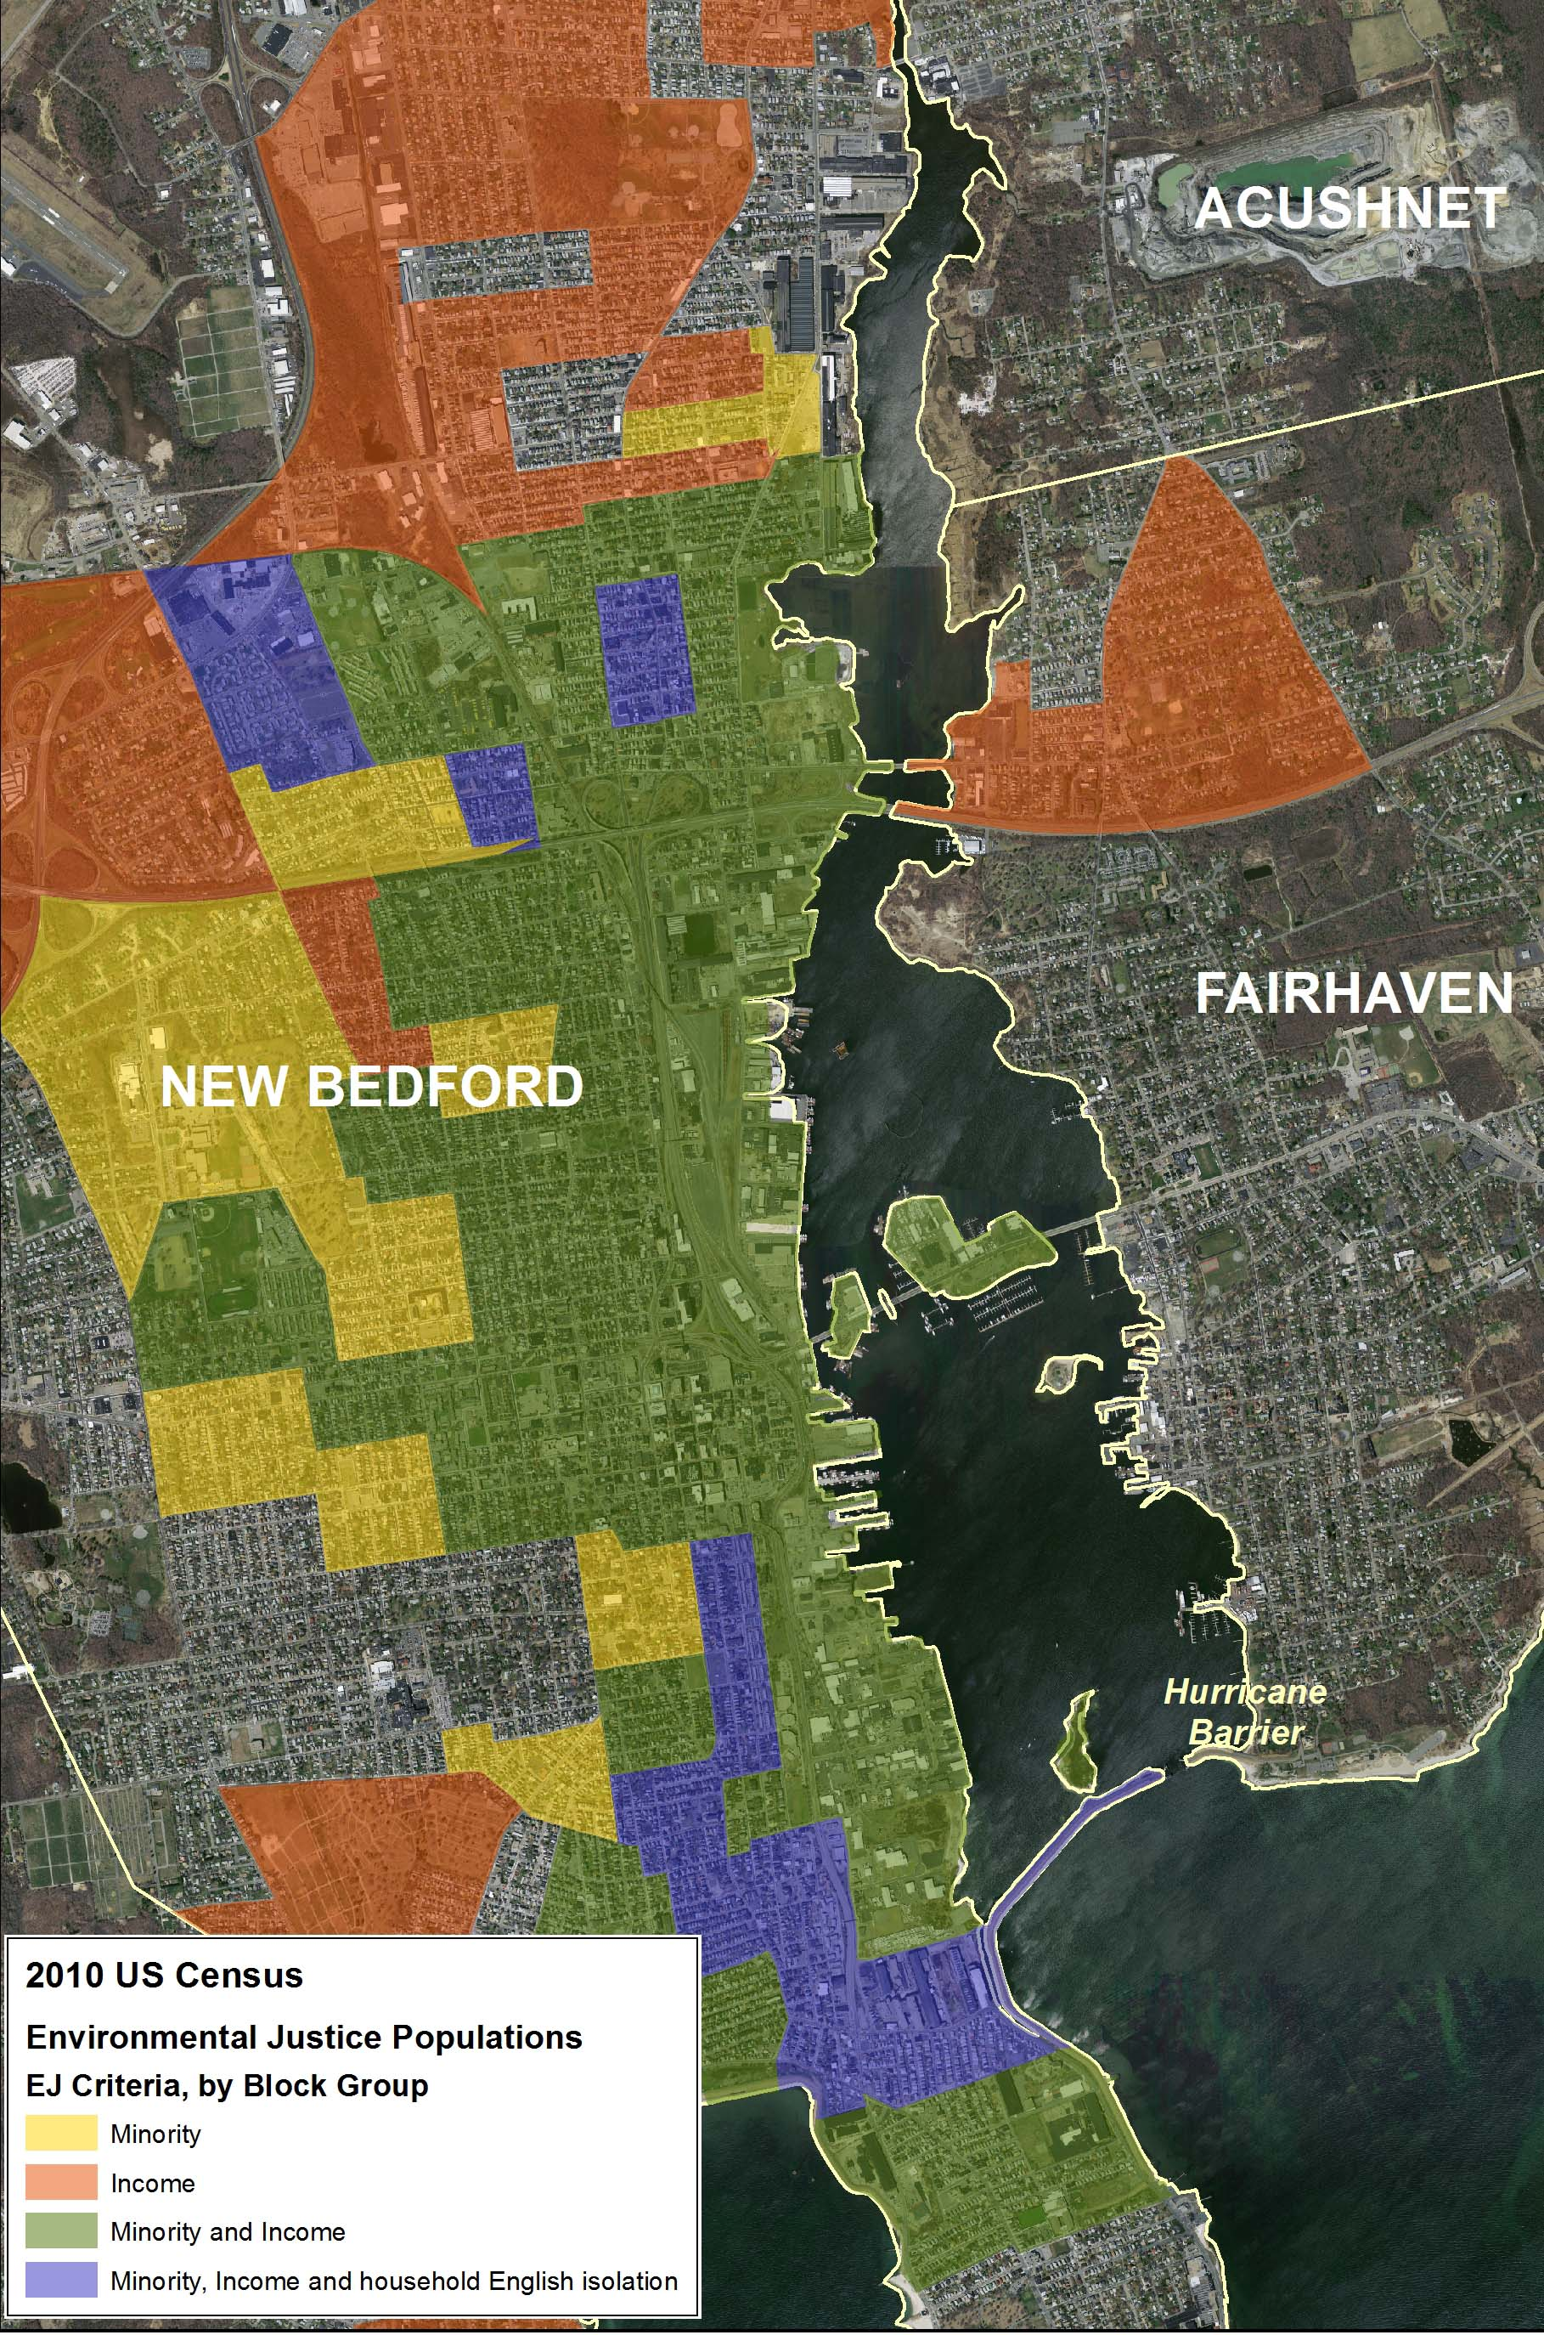
Figure 1. 2010 US Census Environmental Justice areas around New Bedford Harbor.

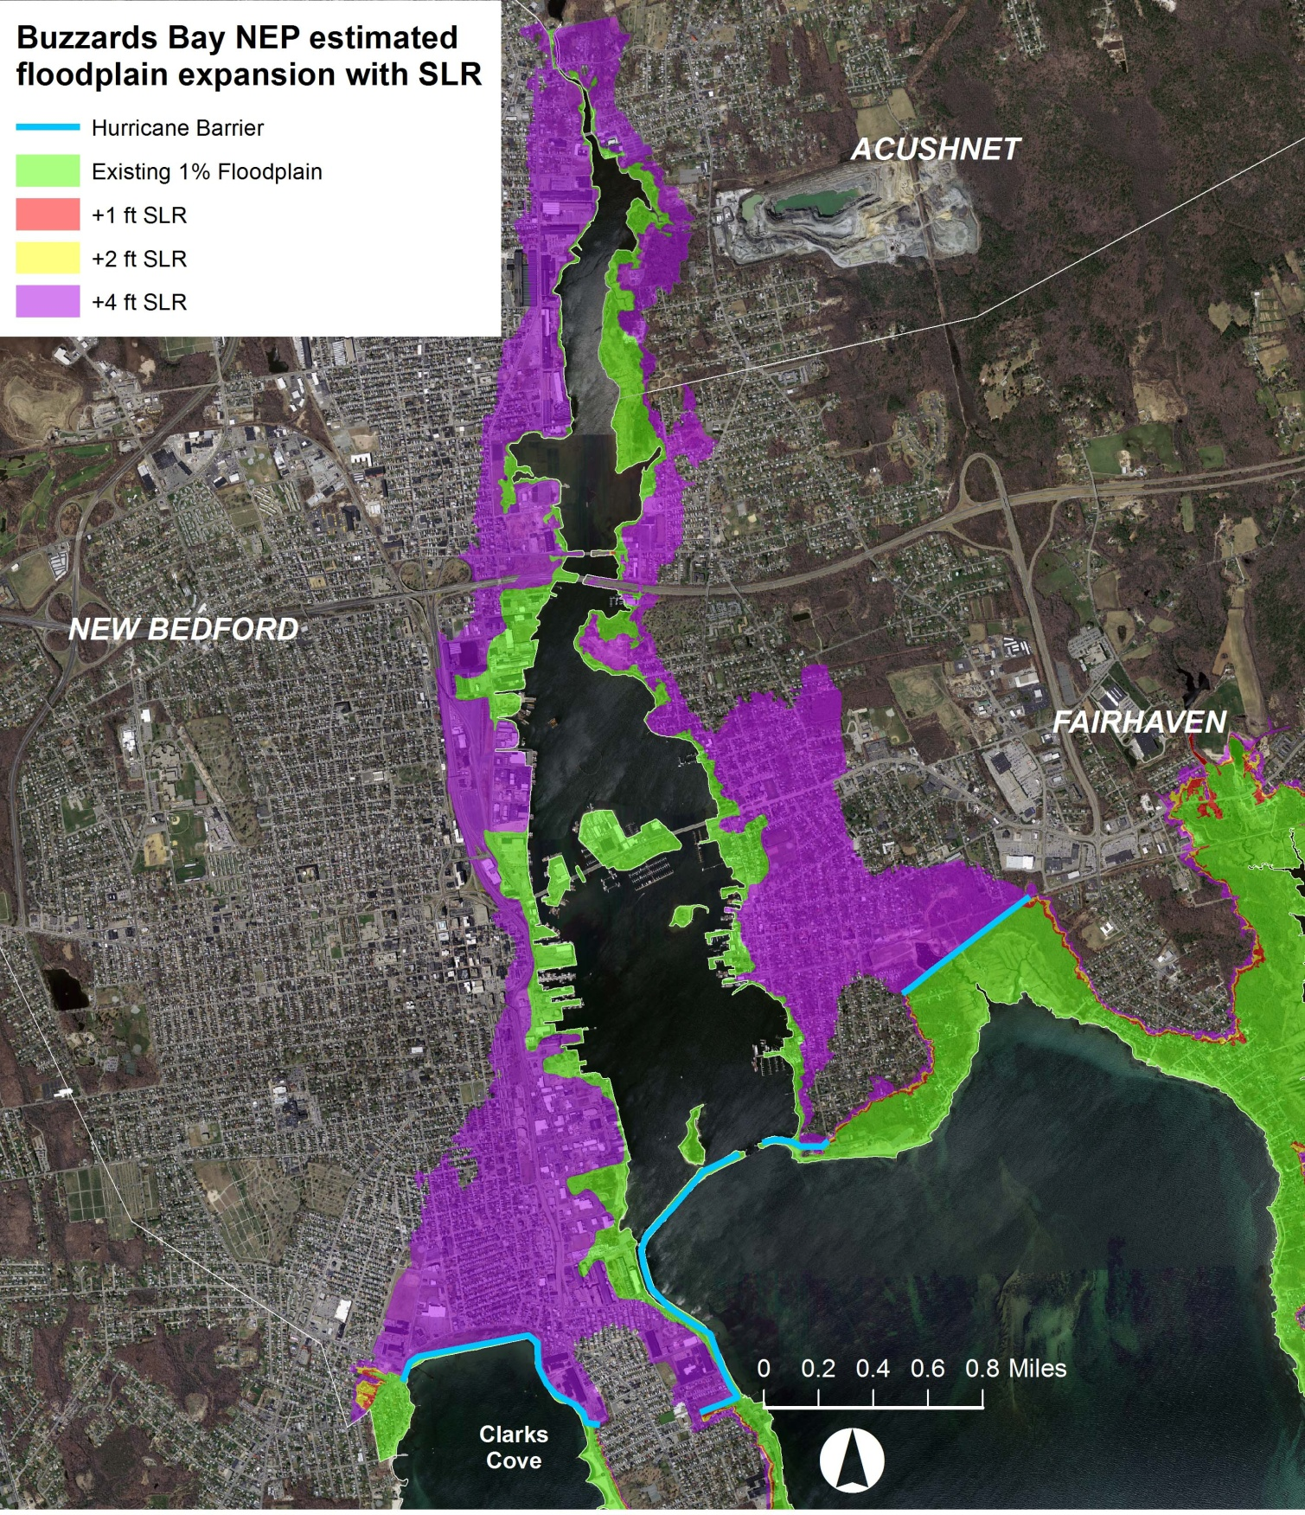
Figure 2 Area of inundation in New Bedford Harbor that would be impacted by a 1% annual chance ("100-year") storm (green) versus the area that would be affected by a 4-foot sea level rise (shaded purple) given current expected storm intensities. This 4-foot sea level rise (SLR) area is roughly equivalent to the flood zone for an exceptional (i.e. 0.2% annual chance or "500-year") storm under current conditions. This area shaded purple behind the hurricane barrier is not under the jurisdiction of the federal flood insurance program because it is currently protected by the hurricane barrier (shaded light blue), so these property owners have no flood insurance.

Attachment B:

Climate Change Vulnerability Assessment and Adaptation Planning Study for Water Quality Infrastructure in New Bedford, Fairhaven and Acushnet

ENV 14 CZM 02

Vendor: ______________________________________________

Amount Requested:_______ ___Reviewer: __________________________Total Pts______ (20 pts max)
Rank among all proposals received: ____ (1= best) of ____ (total)

1) Description of the Approach to the Proposed Work ______ pts (12 points max)
Detail provided in the response including the project approach, timeline, and all other minimum submittal requirements, as well as a demonstrated understanding of project goals and scope. Scoring may include any value added services provided.
Reviewer Comments:

2) Past Experience ______ pts (4 points max)
Rate the vendor’s experience, with similar climate change vulnerability assessment and adaptation planning studies for water quality infrastructure. Rate the vendor’s experience in terms of years and numbers of projects.
Reviewer Comments:

3) References for Performance Evaluation ______ pts (4 points max)
Rate the vendor’s references from clients from related projects to help characterize the firm's experience in completing projects on a timely basis and within the appropriated budget, and their ability to work collaboratively with government agencies.
Reviewer Comments:

Funding is dependent on final rank score, with the highest scored proposal receiving funding. In the case of a tie score, funding will go to the proposal with the lowest cost. The review committee reserves the right to reject any or all proposals that do not meet the goals and terms of this RFR.

Overall Comments:

Reviewer Signature:____________________________ Date:___________
Attachment C:
Cover Sheet

EXECUTIVE OFFICE OF ENERGY AND ENVIRONMENTAL AFFAIRS
OFFICE OF COASTAL ZONE MANAGEMENT
BUZZARDS BAY NATIONAL ESTUARY PROGRAM

REQUEST FOR RESPONSES

Climate Change Vulnerability Assessment and Adaptation Planning Study for Water Quality Infrastructure in New Bedford, Fairhaven and Acushnet

ENV 14 CZM 02
September 5, 2013

Vendor: ______________________________________________________________________

Proposal contact: ____________________________________Title:______________________

Phone: __________________________ Fax:_____________________________

Email: ___________________________________________________________

Mailing Address: ___________________________________________________

_________________________________________________________________

Project manager (if different):__________________________________Title:_______________

Phone: __________________________ Fax:_____________________________

Email: ___________________________________________________________

Mailing Address: ___________________________________________________

_________________________________________________________________

Proposal Amount: $____________
Attachment D
EEA Supplemental Terms & Conditions

See attached sheet on Comm-Pass solicitation under Forms & Terms tab.

Webler, T., Tuler, S.P., and Pignatelli, T. M. (2012). Results from a VCAPS planning workshop for extreme weather and climate change in New Bedford and Fairhaven, Massachusetts: Final report. Social and Environmental Research Institute: Greenfield MA. Available at: www.serius. org/content/MA-Coastal-Hazard-Mitigation-Planning

